**Chapter I**

**INTRODUCTION**

**Background of the Study**

Artificial Intelligence (AI) has brought about significant changes to various aspects of our lives, including the job market (Makridakis, 2017). An alumni tracker system is a software application that allows educational institutions to monitor the career development of alumni, provide career resources, and gather data to enhance the efficacy of programs and services while maintaining alumni engagement. The integration of AI algorithms in the development of the Alumni Tracker with Job Matching system has enabled job seekers to find personalized job recommendations based on their skills and qualifications.

The Alumni Tracker with Job Matching using AI Integration system will collect and analyze data on alumni's education, work experience, skills, and preferences to provide personalized job recommendations. This system will help alumni stay informed about the latest trends in the job market by providing up-to-date information on job openings and the skills and qualifications required to succeed in those roles. Using AI algorithms, the system will match alumni with job openings that are a good fit, enabling employers to find qualified candidates for their job openings.

The development of the Alumni Tracker with Job Matching system using Hybrid filtering a combination of content based filtering and collaborative filtering algorithm, highlights the commitment of NONESCOST to support its alumni in achieving success in their chosen careers. This system's innovative approach sets it apart from other alumni tracker systems that may rely on manual processes or limited data analysis. The personalized job recommendations and up-to-date information on job openings provided by the system are crucial features that will help alumni navigate the competitive job market and find opportunities that match their profile.

**Objectives of the Study**

**General Objective**

This study aims to develop an Alumni Tracker with Job Matching using AI Integration.

**Specifically, it aims to**

1. Design a system that will manage the following data of NONESCOST Alumni:
   * 1. education
     2. work experience
     3. skills
     4. job preferences
2. Design a system that will integrate Artificial Intelligence in the following aspects:
   1. Job matching algorithm that can analyze alumni data and provide personalized job recommendations.
   2. Natural Language Processing (NLP) algorithm to analyze text and provide suggestions for improving grammar, punctuation, style, tone, and clarity.
3. Generate the following reports
   1. Alumni Report
   2. Employer Report
   3. Employment Rate Report
   4. Job Posting Report
4. Determine the quality of the developed system based on **ISO/IEC 25010:2011** Systems and Software Quality Requirements and Evaluation (SQuaRE) Quality Model

**Scope and Limitation**

The scope of this study is to develop an Alumni Tracker with Job Matching system using artificial intelligence (AI) to support the alumni of the Northern Negros State College of Science and Technology (NONESCOST) in finding job opportunities that match their skills and qualifications. The system will collect data on alumni's education, work experience, skills, and preferences to provide personalized job recommendations. The system will also integrate job postings to match alumni with job openings that are a good fit. The system's primary goal is to help alumni achieve success in their chosen careers by connecting them with job opportunities that meet their needs and qualifications.

The Alumni Tracker with Job Matching system has a few limitations that should be taken into account. Firstly, the system is dependent on the data provided by alumni, and if alumni do not provide accurate or up-to-date information, the system's effectiveness may be compromised. Secondly, the system's matching algorithms may not always provide perfect job matches, and it is the responsibility of the job seeker to evaluate the job opportunities presented by the system. Additionally, the system's effectiveness may be limited by the availability of job postings in the database, and it may not be able to capture all job opportunities in the job market. Finally, the system's effectiveness may be limited to the specific region or job market in which it is deployed, and its scalability to a wider range of job markets may require further research and development.

**Significance of the Study**

The NONESCOST Alumni Tracker with Job Matching using AI Integration system is designed to benefit several stakeholders, including NONESCOST alumni, employers, and the academic institution itself.

**NONESCOST Alumni**. The primary beneficiaries of the system are the alumni of the institution. The system will provide personalized job recommendations that match the alumni's education level, work experience, skills, and job preferences. The system will help alumni find job opportunities that align with their career goals, increasing their chances of finding employment that matches their interests and skillset.

**Employers.** The system will benefit employers by providing a pool of qualified job applicants who match their job requirements. Employers will benefit from a more efficient recruitment process, reducing the time and resources required to find suitable candidates. The system will help employers find qualified applicants who match their job requirements, increasing the likelihood of successful job placements.

**Academic Institution.** The system will benefit the academic institution by improving its alumni engagement and support services. By providing a job matching service for alumni, the institution can enhance its reputation and improve its relationships with alumni. The system will also provide valuable data on alumni employment trends, which can be used to improve the institution's academic programs and curriculum.

**Future Researchers.** The project may serve as a reference for future researchers.

**Definition of Terms**

**AI Integration**: Conceptually, AI integration refers to the use of artificial intelligence algorithms and techniques to enhance the performance and capabilities of a system. Operationally, AI integration in the NONESCOST Alumni Tracker system refers to the use of machine learning algorithms to analyze alumni data and provide personalized job recommendations.

**Job Matching**: Conceptually, job matching refers to the process of matching job seekers with suitable job opportunities based on their skills, education, work experience, and job preferences. Operationally, job matching in the NONESCOST Alumni Tracker system refers to the algorithmic process of analyzing alumni data and employer job requirements to identify suitable job opportunities for alumni.

**Alumni Tracker:** Conceptually, an alumni tracker refers to a system that tracks the academic and employment progress of alumni. Operationally, the Alumni Tracker in the NONESCOST system refers to the database and user interface that enables alumni to input and update their personal and employment information, which is used by the job matching algorithm to provide personalized job recommendations.

**Data Analytics:** Conceptually, data analytics refers to the process of analyzing and interpreting data to derive insights and make informed decisions. Operationally, data analytics in the NONESCOST Alumni Tracker system refers to the use of machine learning algorithms to analyze alumni data and employer job requirements to provide personalized job recommendations.

**Personalized Job Recommendations:** Conceptually, personalized job recommendations refer to job opportunities that match the job seeker's skills, education, work experience, and job preferences. Operationally, personalized job recommendations in the NONESCOST Alumni Tracker system refer to the algorithmic process of analyzing alumni data and employer job requirements to identify suitable job opportunities for alumni.

**Conceptual Framework**

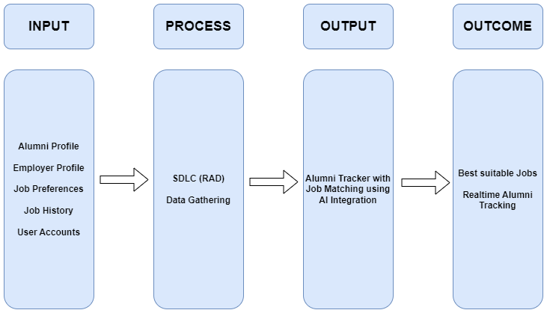

**Figure 1. Conceptual Framework of the Study**

Figure 1 shows the NONESCOST Alumni Tracker with Job Matching system that uses AI integration to match alumni with job openings. The system is based on the IPOO model and enables employers to find qualified candidates for their job openings while also providing real-time tracking of NONESCOST alumni. In summary, it is a tool that simplifies the job matching process and enhances the tracking of alumni.

**Chapter II**

**RELATED LITERATURE AND PRIOR ARTS SEARCH**

**Related Literatures**

**ALUMNI TRACKING SYSTEM**

Jaiswal et al., (2021) proposes an online-based application, the Alumni Tracking System, to enhance the current tracking process of college graduates. The system provides a centralized platform for the management of alumni data and facilitates communication between alumni and the institution. The proposed system offers great advantages to the alumni, such as reducing maintenance effort and providing an all-in-one solution for collecting and managing alumni data.

**An Alumni Portal and Tracking System**

Bista et al., (2021) describes a web-based alumni tracking system that aims to manage alumni data and provide a platform for alumni to update their information and view online yearbooks. The study presents insights from alumni responses, including job positions, employers, current location, and further education preferences. The system has been effective in managing alumni data and has been accessed by many alumni, highlighting the importance of an efficient alumni tracking system for institutions.

**Design and Development of Alumni Tracking Information System**

Suryana et al., (2020) developed and evaluated a web-based alumni tracking information system for SMKN 1 Garut using a waterfall model and functional testing. The system was found to be feasible and received a positive response from alumni users. The research highlights the importance of implementing an efficient alumni tracking system and the benefits of a web-based platform for managing alumni data.

**Design and Development of Alumni Tracking System for Public and Private HEIs**

Luciano et al., (2020) developed an alumni tracing system that would allow the University to track its graduates using the internet, providing important information such as their employment status and essential skills required for their current job. The system can generate comprehensive reports for planning, program implementation, and decision-making purposes. This study emphasizes the importance of an efficient alumni tracking system in providing feedback to HEIs to improve their curriculum and ensure that it meets the needs of the industry.

**Centralized Alumni Management System (CAMS) - A Prototype Proposal**

Mukherjee et al., (2019) proposed a centralized system for alumni management that focuses on alumni networks across institutions and organizations, with a fundamental goal of promoting mentorship processes within and across institutions. The system allows individuals to register as alumni not only after graduation but also while still in school, thereby facilitating networking among professionals and students. The proposed system offers several benefits to both alumni and institutions/organizations and exhibits superior features compared to existing proposals.

**Alumni Social Networking Site**

Sivakumari et al. (2021) proposed an innovative solution for keeping alumni engaged by developing a user-friendly alumni website and social networking platform. The platform provides easy access to career guidance and opportunities for students, as well as networking opportunities with alumnae. The user-friendly interface allows easy communication and sharing of information, which helps to maintain a strong relationship between the institution and its alumni. The project aims to create a platform that supports the career development of students while helping institutions keep track of their alumni.

**Alumni Database Management System**

The system proposed by Kumar et al. (2019) offers a practical solution for managing alumni data and promoting interaction between alumni, administrators, and students in a college setting. By providing a platform for students to connect with alumni for potential projects or job opportunities, the system can enhance their academic and career development. The automatic transfer of student data to the alumni module upon graduation further streamlines the process and ensures accurate alumni records.

**Alumni Interactive System Using Mining**

The study of Patel et al., (2017) highlights the potential of using data mining algorithms in university alumni systems to strengthen the bond between alumni and their former institution. By providing a platform for ongoing interaction between graduates and current students, the proposed system could help facilitate career and business opportunities. Additionally, the use of basic data mining algorithms may improve the user experience of the system. Overall, this study offers valuable insights into the potential benefits of incorporating data mining algorithms into university alumni systems.

**The Alumni Information Management Model Based on "Internet +”.**

Dai et al., (2017) proposes an intelligent integrated alumni information management system framework that combines online and offline approaches to address the existing problems in alumni management such as fragmentation of alumni information and time, delay in information transmission, and simplification of management system function. The proposed framework includes three modules: "Alumni Social Network," "Intelligent Data Acquisition and Storage," and "Data Mining and Decision-Making Support," and aims to build a social platform for alumni network while using intelligent technology to collect and store massive alumni data and datamining technology to improve decision-making for talent training schemes. The system is designed to leverage "Internet+" to enhance alumni management work.

**Designing Mobile Alumni Tracer Study System Using Waterfall Method: an Android Based.**

Sadi et al. (2019) conducted a study to address the lack of systematic compilation and minimal alumni data in the Industrial Engineering Department at UPN Veteran Yogyakarta, Indonesia by developing an Android application for tracking alumni. The research utilized qualitative descriptive methodology and a prototyping system development method to collect data through interviews and observation, with expected results of an Android application for alumni search, analysis of alumni data, and a survey approach to describe graduates' profiles and curriculum relevance.

**ATS ANALYSIS, DESIGN AND DEVELOPMENT OF THE ALUMNI TRACKING SYSTEM OF THE LICERIO ANTIPORDA SR. NATIONAL HIGH SCHOOL-DALAYA EXTENSION**

The study conducted by Umoso (2021) aimed to improve the tracking of alumni at Licerio Antiporda Sr. National High School- Dalaya Extension by designing and developing an online-based alumni tracking system. The study identified the problems and limitations of the existing manual system and implemented the proposed software platform to address these issues. The newly developed system offers great advantages such as easy access to alumni data and communication between alumni and the institution. The study's findings suggest that the implementation of the online Alumni Tracking System is a potential technological tool that can contribute to the development of the school's management program while reflecting on the status of its alumni. Overall, the study's methodology and proposed system provide a valuable contribution to alumni tracking systems in educational institutions.

**DIGITAL SKILL: OPTIMIZING THE UTILIZATION OF INFORMATION TECHNOLOGY BY PESANTREN UNIVERSITY IN ALUMNI TRACKING ACTIVITIES**

This research by Setyaningsih et al.,(2022) explore the implementation of a tracer study at Universitas Darussalam Gontor by optimizing information technology and using a website-based alumni tracking system. The study utilized a qualitative case study approach and data was collected through interviews and observations. The results showed that the tracer study had optimized the use of information technology in the form of a google form and a website-based alumni tracking system was being developed, while recommendations were made for increasing skills and knowledge for optimizing the use of the website-based system.

[**A LinkedIn Analysis of Career Paths of Information Systems Alumni**](https://aisel.aisnet.org/cgi/viewcontent.cgi?article=1007&context=jsais)

The study conducted by Case et al., (2013) examines the extent to which LinkedIn profiles can provide a more realistic picture of entry-level jobs held by Information Systems program alumni and their subsequent career progress. The investigation used information from 175 graduates of the program at a mid-sized comprehensive university in the southeastern USA, and suggests that LinkedIn profiles can be used to assess long-term outcomes of IS programs, answer questions about career paths for IS professionals, and evaluate the transition from technical to managerial positions.

**An Alumni Tracer System for Saint Louis College**

The aim of the study proposed by Hufana(2019) was to develop an Alumni Tracer System for Saint Louis College using the Software Engineering Process. The developed system was tested for usability by IT experts using the WUCET test and by the Alumni Affairs and Job Placement Officer and selected alumni using the WAMMI tool, and was found to have a high level of usability, addressing the constraints of the existing Alumni Tracer System. The study recommends the adoption of the developed Alumni Tracer System by Saint Louis College.

**Tracer Study as an Effort to Improve Alumni Careers in Kadiri University Job Placement Service.**

Safi'I & Priyantoro (2019) conducted a quantitative descriptive study with a cross-sectional approach is to investigate the transition of graduates from education to the world of work, alumni assessment of higher education's contribution to obtaining competencies, and vertical and horizontal alignment felt by alumni. The target population is 2419, with a total of 955 contactable alumni, and 195 alumni responded to the questionnaire. The findings suggest that alumni take an average of six months to secure a job, with most job searches done through personal connections, and private companies are the most common type of workplace. Additionally, the majority of respondents felt that their competencies were vertically and horizontally aligned.

**Web-Based Abulyatama Alumni Information System**

Ardiansyah (2021) developed a web-based E-Tracer study service for STMIK Abulyatama to improve the existing manual system for collecting data on alumni. The objectives of the research are to analyze the alumni information system, design and develop the alumni management information system, and improve the existing system for better performance in alumni data collection. The proposed system is expected to provide more accurate and up-to-date information about alumni, simplify and speed up administrative processes, and benefit curriculum improvements.

**Developing a Tracer Study Information System Based on SMS Gateway to Support Career Development Program in UPI, Cibiru Campus.**

Permana (2019) designed an information system based on SMS Gateway technology to provide job-related information to UPI Kampus Cibiru graduates quickly and sustainably in accordance with their scientific fields. The Rapid Application Development method is used in this study to design the system, which is built using HTML Programming Language, PHP, and Bootstrap as a CSS framework. The proposed system is expected to improve the absorption of UPI Kampus Cibiru graduates in the working environment and serve as an indicator of the institution's success in organizing the educational process.

**Dashboard-based Alumni Tracer Study Report Using Normalized Data Store Architecture.**

The research by Asroni et al., (2019) aims to develop a data warehouse using the NDS architecture for alumni monitoring at Universitas Muhammadiyah Yogyakarta. The study found some noise in the data, such as null data and duplication of data, which were cleaned during the process. The data warehouse met the institution's requirements and was displayed in a report that was easier to analyze, and the report was made into a dashboard form using the Power BI application.

**E-tracer study implementation of Indonesia Computer University alumni.**

The study of Soegoto et al., (2018) describes the tracer study conducted by Indonesia Computer University in 2016 for its 2014 graduates using an online survey through various communication channels. The research focuses on the response rate and alumni characteristics, such as their transition period, job relevance, and competence. The results show a 28% response rate, a median transition period of four months, and a zero competence gap in research skills, indicating the university's success in achieving its graduates' aim in this area.

**Development of Industry Academe Linkage Alumni and Placement Portal.**

The study conducted by Rosales & Lagman (2017) aimed to develop an Industry Academe Linkage Alumni and Placement Portal for FEU Institute of Technology, which would automate the workflow and processes of interns for industry placement and tracking of alumni. The study employed the Incremental Model Process as the software process model and the ISO 9126 for determining the acceptability of the developed prototype based on criteria such as functionality, usability, reliability, portability, and supportability. The overall evaluation of the system is 4.21, indicating that the application is satisfactory and ready for deployment.

**Prior Arts**

**A career counseling system based on intelligent matching algorithms.**

According to Fernandez & Saboia (2021) this paper describes a career counseling system that uses intelligent matching algorithms to help individuals find suitable job opportunities based on their skills and interests.

**A job matching system based on ontology and machine learning.**

Wang & Yao (2019) article presents a job matching system that uses ontology and machine learning to match job seekers with suitable job opportunities based on their skills and qualifications.

**A job recommendation system based on multi-criteria decision making**

Zhu et al., (2018) proposes a job recommendation system that uses multi-criteria decision making to recommend job opportunities based on the preferences and qualifications of job seekers.

**A method for using natural language processing to match job seekers with suitable job postings.**

Roush (2017) article describes a method for using natural language processing to match job seekers with suitable job postings based on their skills and qualifications.

**An intelligent job matching system based on deep learning.**

According to Zhang et al., (2019) the paper proposes an intelligent job matching system that uses deep learning algorithms to match job seekers with suitable job opportunities based on their skills and qualifications.

**A hybrid approach for job recommendation using collaborative filtering and content-based filtering.**

This article of Ghorbani et al., (2018) presents a hybrid approach for job recommendation that combines collaborative filtering and content-based filtering to recommend job opportunities based on the preferences and qualifications of job seekers.

**A job matching model based on artificial neural network.**

Wang et al., (2018) proposes a job matching model that uses artificial neural networks to match job seekers with suitable job opportunities based on their skills and qualifications.

**Job matching based on ontology and semantic matching.**

Chen et al., (2020) presents a job matching approach that uses ontology and semantic matching to match job seekers with suitable job opportunities based on their skills and qualifications.

**Job matching system based on personality traits and skills.**

Purohit & Kulkarni (2019) proposes a job matching system that uses personality traits and skills to match job seekers with suitable job opportunities.

**Predicting career outcomes using natural language processing and machine learning**

Raza & Murad (2020) study uses natural language processing and machine learning to analyze alumni career data and predict future career outcomes.

**Intelligent career counseling system using data mining techniques**

Tsai (2013) study proposes an intelligent career counseling system that uses data mining techniques to match job seekers with suitable careers.

**A hybrid intelligent system for job matching and career recommendation**

Nandhini & Prakash (2015) study proposes a hybrid intelligent system that combines fuzzy logic, case-based reasoning, and genetic algorithms to match job seekers with suitable careers.

**Development of an intelligent career counseling system using association rule mining**

Kim et al., (2015) study proposes an intelligent career counseling system that uses association rule mining to match job seekers with suitable careers.

**Job recommendation system using machine learning algorithms**

Xia et al., (2021) study proposes a job recommendation system that uses machine learning algorithms to match job seekers with suitable job opportunities.

**A fuzzy logic-based intelligent job matching system**

Li & Tsai (2012) study proposes an intelligent job matching system that uses fuzzy logic to match job seekers with suitable job opportunities.

**Intelligent career path recommendation system using machine learning algorithms**

Lee (2018) study proposes an intelligent career path recommendation system that uses machine learning algorithms to recommend suitable career paths for job seekers.

**A career guidance system based on clustering analysis**

Kwon et al., (2015) study proposes a career guidance system that uses clustering analysis to match job seekers with suitable careers.

**An intelligent job matching system using rule-based reasoning**

Lee (2016) study proposes an intelligent job matching system that uses rule-based reasoning to match job seekers with suitable job opportunities.

**A semantic approach to job matching**

Lee et al., (2014) study proposes a semantic approach to job matching that uses ontologies to match job seekers with suitable job opportunities.

**A web-based intelligent job recommendation system using collaborative filtering**

Jiang et al., (2018) study proposes a web-based intelligent job recommendation system that uses collaborative filtering to match job seekers with suitable job opportunities.

**Synthesis**

Based on the related literature and prior arts, it is evident that there is a growing need for job matching systems that can help alumni find suitable job opportunities based on their skills, qualifications, and preferences. These systems often use intelligent algorithms, such as machine learning and natural language processing, to match alumni job seekers with job postings that meet their criteria.

**Chapter III**

**METHODOLOGY**

**System Design**

The researcher used the iterative approach which is a methodology that involves breaking a project into smaller parts and completing those parts in an iterative process, constantly reviewing and refining the work as needed. This approach allows for greater flexibility and adaptability, and can help catch errors early on, ultimately leading to a higher-quality final product.

**Figure 2. Agile Software Development**

The **Agile** methodology focuses on providing value to end-users and prioritizes collaboration, flexibility, and continuous improvement. The model has five phases which are: Requirements, Design, Development, Testing, Deployment and Review. The project utilizes AI algorithms, including Hybrid Filtering, Collaborative Filtering, User Based Content Filtering, and NLP algorithm, to develop an effective job matching system.

**Software Life Cycle Model**

**Requirements Gathering**: In this phase, the researcher needs to identify the specific requirements for the software development project. One crucial requirement is the need for a large amount of data related to job postings, job requirements, job preferences, and alumni data. This data will be used to train and improve the AI algorithms used in the system, particularly the Hybrid Filtering, Collaborative Filtering, User-Based Content Filtering, and NLP algorithms.

**Design**: In this phase, the overall design of the software is created, including the architecture, user interface, and database schema. The design should be capable of incorporating the AI algorithms identified in the previous phase, with appropriate data sources and integration of the algorithms to ensure effective job matching.

**Development**: In the development phase, the project team will work with the datasets to develop and test the AI algorithms. The data will be used to train the algorithms to identify patterns and relationships between job postings and alumni data. The team will use different techniques, such as supervised and unsupervised learning, to ensure that the algorithms can accurately match alumni with relevant job opportunities.

**Testing**: In this phase, the software is tested to ensure that it meets the requirements and is free of errors. AI algorithms should be tested to ensure they are functioning effectively and providing accurate job matching results.

**Deployment**: In this phase, the software is deployed to the production environment. The AI algorithms should be integrated and fully operational within the system, ready to provide job matching services to alumni.

**Maintenance**: In this phase, the software is maintained and updated as needed. The AI algorithms should be continuously monitored to ensure they are providing accurate job matching results, and updated as necessary to improve their performance.

**Data Gathering Procedure**

The proponent used different data gathering tools which helped gather relevant information to achieve the goal of the proposed study. Here are the data gathering tools:

1. Observation. The researcher conducted observations to collect information about alumni and their job preferences, as well as to gather data on job postings and employer requirements.
2. Interview. The researcher conducted interviews with the stakeholders including alumni, employers and the administrator, as they provide rich, detailed data on alumni's career goals, job preferences, skills, and experience. This data can be used to develop AI algorithms that provide personalized job recommendations and improve the overall effectiveness of the platform.
3. Internet Research. The researcher gathered additional information through the internet related to the study.
4. Survey questionnaire. The proponent provided surveys to all the users of the system for them to comment or write what are the needs and don’t to the system made by the proponent.

**Data Analysis Procedure**

The data that were collected were analyzed using mean and grand mean with corresponding verbal interpretations.

**Reliability and Validity of Research Instrument**

The questionnaires were duly reviewed and validated by three (3) experts using the Carter V. Good and Douglas F. Scates tool in validating and evaluating a questionnaire. Results showed a grand mean of 4.79 which is interpreted as valid.

The self-made questionnaire has undergone a reliability test from a group of thirty (30) alumni in Barangay Old Sagay, Sagay City. Result is shown in Table 2.0.

**Table 2.0**

**Reliability and Statistics**

|  |  |
| --- | --- |
| **Cronbach’s Alpha** | **N of items** |
| 0.809 | 18 |

Reliability refers to the consistency and stability of measurement or data collection methods, ensuring that similar results can be obtained under consistent conditions, as described by Babbie (2017). In the conduct of the reliability, a dry run was conducted to 30 alumni of the school. To determine the coefficient of correlation, Cronbach Alpha was used.

The computed alpha was 0.809. According to DeVellis (2017), a coefficient of 0.7 or higher indicates high reliability. This means that the research instrument developed by the researcher was reliable to a high degree.

**Context Flow Diagram**

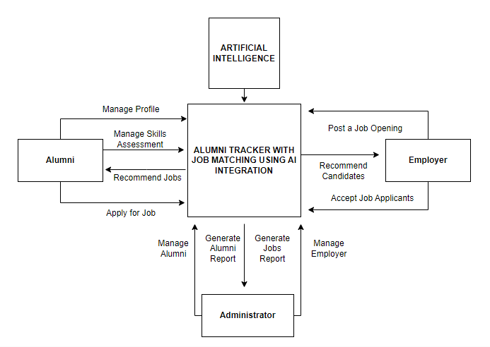

**Figure 3. Context Flow Diagram**

Figure 3 shows how the researcher maps out on how the entire features and components of the system will work together according to its purpose. In this figure, there are three main external entities: alumni, administrator, and employers. The integration of Artificial Intelligence.

**Data Flow Diagram**

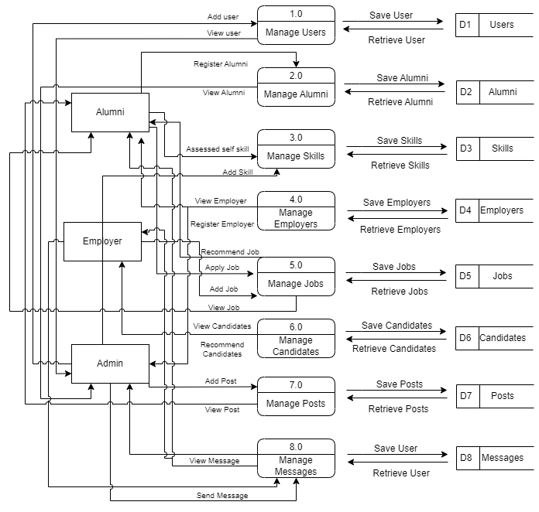

**Figure 4. Data Flow Diagram**

Figure 4 illustrates how information is processed within the system, including where it comes from, how it is transformed, and where it is stored. The purpose of the Data Flow Diagram is to depict the system's scope and boundaries, and it can be used as a tool for communication between the systems analyst and stakeholders involved in the system's redesign.

**Entity-Relationship Diagram**

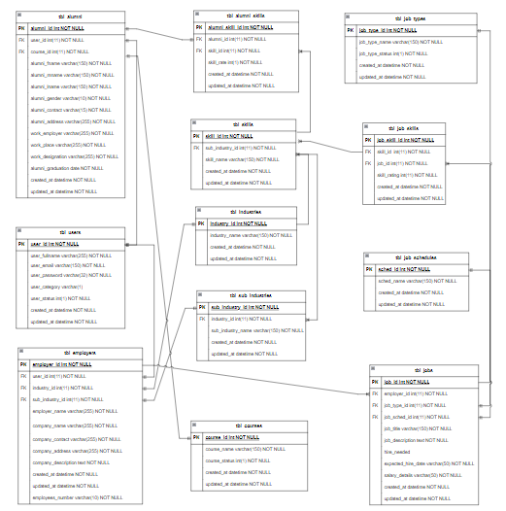

**Figure 5. Entity Relationship Diagram**

An entity relationship diagram gives a snapshot of how these entities relate to each other. You could call it the blueprint that underpins your system architecture, offering a visual representation of the relationships between different sets of data (entities) as shown in Figure 5.

**Application Architecture**

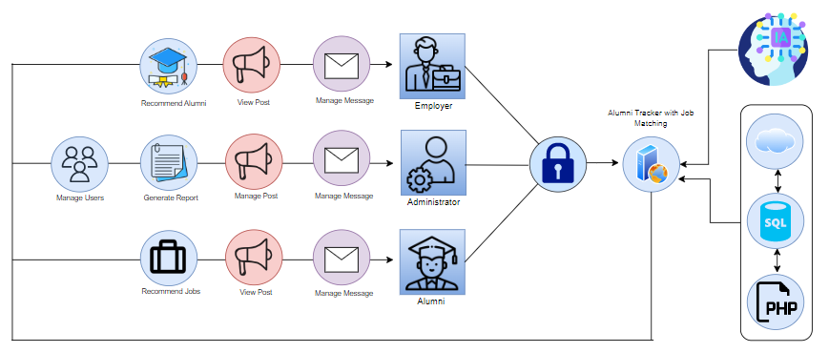

**Figure 6. Application Architecture**

Figure 6 shows how the system will work when used by the registered users. In this architecture, the system is built around a web server, which serves as the entry point for incoming requests. The Job Portal component handles requests from alumni and job seekers, allowing them to view job postings and apply for relevant positions. The Job Matching Module processes incoming job applications and uses AI algorithms to match alumni with relevant job postings. The Alumni Tracker Module is responsible for managing the data and profiles of alumni, including their personal and professional information. The AI Engine component provides the computing resources needed to run the AI algorithms used in the system.

**Use-Case Diagram**

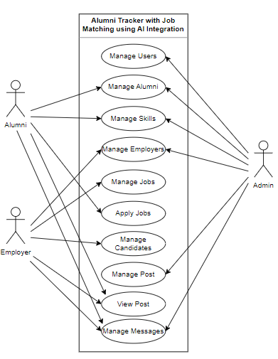

**Figure 7. Use Case Diagram**

A Use Case diagram is a representation of a user's interaction with the system that shows the relationship between the user and the different use cases in which the user is involved as shown in figure 7.

**Software Requirements**

**Table 1.0**

**Software Specifications**

|  |  |
| --- | --- |
| **Requirement** | **Purpose** |
| ***Admin side:*** |  |
| Operating System | To run the administrative interface for the system. Example: Windows 7, 8, or 10 |
| PHP | To develop the server-side components of the system. |
| Web Hosting/Server | To host and deploy the system. Example: Apache or Nginx web server |
| MySQL | To manage the database of the system. |
| Python | To implement various features and algorithms of the system. |
| ***Client side:*** |  |
| Operating System | To run the client-side interface for the system. Example: Windows 7, 8, or 10 |
| Web Browser | To access the system's interface. Example: Google Chrome, Mozilla Firefox |

Table 1.0 presents the software requirements needed in order to operate the program properly.

**Table 2.0**

**Hardware and Other Required Devices**

|  |  |
| --- | --- |
| **Requirement** | **Purpose** |
| ***Hardware and Other Required Devices:*** |  |
| Processor | To handle the computational load of the system. Example: Intel Core i3 or higher |
| RAM | To provide memory resources to run the system efficiently. Example: 2GB or higher |
| Hard Disk Drive | To store the system's files and data. Example: 500GB or higher |
| Printer | To print documents generated by the system. |
| Internet Plan | To ensure the system has a stable and reliable internet connection. Example: at least 5 Mbps |

This section presents the hardware resources needed for the study. The hardware and other required devices are presented in Table 2.

**Cost-Benefit Analysis**

**Table 1.0**

**Developmental Cost**

|  |  |  |  |
| --- | --- | --- | --- |
| **Development Cost** | **Duration** | **Cost** | **Total Amount** |
| Programmer | 2 months | 20,000 | 20,000 |
| System Analyst | 2 months | 20,000 | 20,000 |
| AI Expert | 2 months | 30,000 | 30,000 |
| Computer set 3 |  | 20,000 | 60,000 |
| Internet Fee | 2 months | 1,299 | 2,598 |
| **Subtotal** |  |  | 132,598 |

Table 1.0 shows the developmental cost of the system that includes programmer fee, system analyst fee, AI Expert, cost of computer set, and internet fee which accumulated to 132,598.

**Table 2.0**

**Operational Cost**

|  |  |  |  |
| --- | --- | --- | --- |
| **Operational Cost** | **Duration** | **Cost** | **Total Amount** |
| Electrical Expense | 12 months | 1,000 | 12,000 |
| Internet Fee | 12 months | 1,299 | 15,588 |
| Maintenance Fee | 12 months | 1,500 | 18,000 |
| Cloud server (Hostinger VPS Server Plan 4) | 12 months | 1,629 per month | 19,548 |
| Computer set |  | 20,000 | 20,000 |
| Printer |  | 5,000 | 5,000 |
| **Subtotal** |  |  | **90,136** |

Table 2.0 shows the operational cost of the system that includes electrical expenses, internet fees, maintenance fee, cloud server, computer sets, and printers of alumni administrator which accumulated to 90,136.

**Table 3.0**

**Total Developmental and Operational Cost**

|  |  |
| --- | --- |
|  | **Total Cost** |
| Developmental Cost | 132,598 |
| Operational Cost | 90,136 |
| **Total** | **222,734** |

Table 5.0 shows the total developmental and operational cost of 222,734.

**Table 4.0**

**Benefits of the system**

|  |  |  |  |
| --- | --- | --- | --- |
| **Benefits of the system** | **Duration** | **Cost** | **Total Amount** |
| Improved Job Matching | 12 months | 9,000 | 108,000 |
| Increased Alumni Engagement | 12 months | 6,000 | 72,000 |
| Improved Career Outcomes | 12 months | 8,000 | 96,000 |
| Security of data | 12 months | 3,000 | 36,000 |
| Data backup | 12 months | 4,000 | 48,000 |
| **Total cost benefit** |  |  | **360,000** |

Table 4.0 shows the total cost benefit of the system that includes improved job matching, increased alumni engagement, improved career outcomes, security of data, and data backup which accumulated to 360,000.

**CHAPTER IV**

**PRESENTATION, ANALYSIS, AND INTERPRETATION OF DATA**

After the thorough evaluation of experts and respondents, the following are discovered:

**Figure 8. Alumni’s Profiles**

Figure 8 shows how the alumni can manage his own profiles of the Alumni Tracker with Job Matching using AI Integration. The alumni can update his personal records, which generates an Alumni report.

**Figure 9. Alumni’s Education**

Figure 9 shows how the alumni can manage his own education history of the Alumni Tracker with Job Matching using AI Integration. The alumni can add and manage an education history indicating the school attended, program taken, honor received and the year when he graduated. This will allow the employer to see that candidate education history.

**Figure 10. Alumni’s Work Experience**

Figure 10 shows how the alumni can manage his own work experience history of the Alumni Tracker with Job Matching using AI Integration. The alumni can add and manage work experience history indicating the company, job title, inclusive years and the achievements. This will allow the employer to see that candidate work an experience history.

**Figure 11. Alumni’s Skills Assessment**

Figure 11 shows how the alumni can assess his own skills of the Alumni Tracker with Job Matching using AI Integration. The alumni can assess his skills base on the level of mastery defined as novice, intermediate, proficient, advanced and expert.

**Figure 12. Alumni’s Work Experience**

Figure 12 shows how the alumni can manage his own job preferences of the Alumni Tracker with Job Matching using AI Integration. The alumni can add and manage job preferences indicating the desired job title, salary, type of employment, job schedule and summary of skills and experiences.

**Table 5.0**

**In terms of managing NONESCOST Alumni’s data.**

|  |  |  |
| --- | --- | --- |
|  | **Mean** | **Verbal Interpretation** |
| The system can manage alumni’s profiles. | 4.56 | Very Good |
| The system can manage alumni’s education | 4.5 | Very Good |
| The system can manage alumni’s work experience | 4.44 | Very Good |
| The system can manage alumni’s skills assessment | 4.56 | Very Good |
| The system can manage alumni’s job preferences | 4.5 | Very Good |
| **Total** | **4.51** | **Very Good** |

Table 5.0 shows the result of the users’ feedback on Alumni Tracker with Job Matching using AI Integration in providing alumni to use and access the system enables them to manage their own profiles, manage education history, manage work experience, manage skills assessment and manage job preferences and a rating with a mean value of 4.51 which is interpreted as Very Good.

**Figure 13. Alumni’s Job Matching**

Figure 13 shows the Alumni matched jobs of the Alumni Tracker with Job Matching using AI Integration. The alumni can view the jobs that match its job preferences with a percentage indication.

**Figure 14. Job’s Best Candidate**

Figure 14 shows the Job best candidates of the Alumni Tracker with Job Matching using AI Integration. The employer can view the alumni that match the job preferences with a percentage indication.

**Table 6.0**

**In terms of integrating AI using Job Matching Algorithm to provide personalized job recommendations.**

|  |  |  |
| --- | --- | --- |
|  | **Mean** | **Verbal Interpretation** |
| The system can recommend best jobs for alumni | 4.56 | Very Good |
| The system can recommend best candidates for the job | 4.5 | Very Good |
| **Total** | **4.51** | **Very Good** |

Table 6.0 shows the result of the users’ feedback on Alumni Tracker with Job Matching using AI Integration in providing alumni to use and access the system enables them to view the best jobs that match their preferences, allow employer to view the best candidates and a rating with a mean value of 4.53 which is interpreted as Very Good.

**Figure 15. Alumni Job Preferences with AI**

Figure 15 shows the alumni job preferences with AI of the Alumni Tracker with Job Matching using AI Integration. The alumni can manage its job preferences, analyze text and provide suggestions using Natural Language Processing.

**Table 7.0**

**In terms of integrating AI using Natural Language Processing (NLP) Algorithm to analyze text and providing suggestions.**

|  |  |  |
| --- | --- | --- |
|  | **Mean** | **Verbal Interpretation** |
| The system can analyze text spelling errors and suggest corrections. | 4.5 | Very Good |
| The system can analyze text for grammar errors and provide suggestions for corrections | 4.63 | Very Good |
| **Total** | **4.56** | **Very Good** |

Table 7.0 shows the result of the users’ feedback on Alumni Tracker with Job Matching using AI Integration in providing alumni, employer and admin to use and access the system enables them to view the analyze text and suggestions provided by AI and a rating with a mean value of 4.56 which is interpreted as Very Good.

**Figure 16. Alumni Report per Batch**

Figure 16 shows the alumni report per batch of the Alumni Tracker with Job Matching using AI Integration. The admin can generate an alumni report per batch consists of alumni name, contact number, email address, program, and occupation.

**Figure 17. Alumni Report per College**

Figure 17 shows the alumni report per college of the Alumni Tracker with Job Matching using AI Integration. The admin can generate an alumni report per college consists of alumni name, contact number, email address, program, and occupation.

**Figure 18. Alumni Report per Courses**

Figure 18 shows the alumni report per courses of the Alumni Tracker with Job Matching using AI Integration. The admin can generate an alumni report per courses consists of alumni name, contact number, email address, and occupation.

**Figure 19. Employer Report**

Figure 19 shows the employer report of the Alumni Tracker with Job Matching using AI Integration. The admin can generate an employer report consists of company name, contact number, email address, and industry.

**Figure 20. Employer Report per Industry**

Figure 20 shows the employer report per industry of the Alumni Tracker with Job Matching using AI Integration. The admin can generate an employer report per industry consists of company name, contact number, and email address.

**Figure 21. Job Posting Report per Year**

Figure 21 shows the job posting report per year of the Alumni Tracker with Job Matching using AI Integration. The admin can generate a job posting report per year in graphical form using basic column chart.

**Figure 22. Job Posting Report per month**

Figure 22 shows the job posting report per month of the Alumni Tracker with Job Matching using AI Integration. The admin can generate a job posting report per month in graphical form using basic line chart.

**Table 8.0**

**In terms of generating report**

|  |  |  |
| --- | --- | --- |
|  | **Mean** | **Verbal Interpretation** |
| The system can generate alumni report per batch | 4.69 | Very Good |
| The system can generate alumni report per college | 4.5 | Very Good |
| The system can generate alumni report per course | 4.5 | Very Good |
| The system can generate employer report per industry | 4.75 | Very Good |
| The system can generate employment rate report by batch |  |  |
| The system can generate employment rate report by college |  |  |
| The system can generate employment rate report by course |  |  |
| The system can generate a job posting report per year | 4.81 | Very Good |
| The system can generate a job posting report per month | 4.88 | Very Good |
| **Total** | **4.56** | **Very Good** |

Table 8.0 shows the result of the users’ feedback on Alumni Tracker with Job Matching using AI Integration in providing admin to use and access the system enables them to generate a report of alumni per batch, alumni per college, alumni per program, employer per industry, job posting per year, job posting per month and a rating with a mean value of 4.56 which is interpreted as Very Good.

**Figure 23. Employer Dashboard**

Figure 23 shows the employer dashboard of the Alumni Tracker with Job Matching using AI Integration which allows the employer to navigate through various navigations. The dashboard also displays the total number of jobs posted, total views of jobs posted, total number of candidates, total number of jobs bookmarked.

**Figure 24. Employer Dashboard**

Figure 24 shows the admin dashboard of the Alumni Tracker with Job Matching using AI Integration which allows the employer to navigate through various navigations. The dashboard also displays the total number of alumni, total number of employers, and total number of jobs posted.

**Figure 25. Alumni Dashboard**

Figure 25 shows the alumni dashboard of the Alumni Tracker with Job Matching using AI Integration which allows the alumni to navigate through various navigations. The dashboard also displays the total number of employers, and total number of jobs posted.

In terms of Functional Suitability, the Alumni Tracker with Job Matching using AI Integration provides a wide range of functionalities that allow educational institutions to monitor the career development of alumni, provide career resources, and gather data to enhance the efficacy of programs and services while maintaining alumni engagement. The integration of AI algorithms in the development of the system enables job seekers to find personalized job recommendations based on their skills and qualifications.

In terms of Performance efficiency, the system uses AI algorithms to analyze alumni data and provide personalized job recommendations, ensuring that job seekers find opportunities that match their qualifications and skills. The system's efficient algorithms ensure that the job recommendation process is fast and accurate, enabling alumni to find job opportunities quickly.

In terms of Security, the system ensures the security of alumni data by using encryption and secure servers to protect the data. Additionally, the system requires authentication to access sensitive information, ensuring that only authorized users can access the data.

The reliability of Alumni Tracker with Job Matching using AI Integration is guaranteed through AI algorithms that provide accurate and personalized job recommendations while also allowing for bug reporting. The user-friendly interface and up-to-date information provided to alumni ensure the system meets the usability criterion. The system's use of AI algorithms also ensures maintainability, allowing developers to update the system to adapt to changes in the job market. Additionally, the system is highly portable and compatible with different web browsers and operating systems, meeting the portability and compatibility criteria, respectively.

**Table 11.0**

**In terms of the characteristics set in ISO 25010 Software Quality Model**

|  |  |  |
| --- | --- | --- |
| **Criteria** | **Mean** | **Verbal Interpretation** |
| Functional Suitability | 5 | Very Good |
| Performance Efficiency | 5 | Very Good |
| Compatibility | 4.66 | Very Good |
| Usability | 4.33 | Good |
| Reliability | 5 | Very Good |
| Security | 4.66 | Very Good |
| Maintainability | 5 | Very Good |
| Portability | 4.66 | Very Good |
| **Total** | **4.79** | **Very Good** |

Table 13.0 shows the result of the IT Experts' feedback in determining the quality of the NONESCOST Alumni Tracker with Job Matching using AI Integration based on the characteristics set in the ISO 25010 Software Quality Model.

In terms of Functional Suitability, Performance Efficiency, Reliability and Maintainability, it was rated with a mean value of 5, which is interpreted as Very Good. With regards to Compatibility, Security and Portability, it was rated with a mean value of 4.66, which is interpreted as Very Good. Concerning Usability, it was rated with a mean value of 4.33, which is interpreted as Good.

**CHAPTER V**

**SUMMARY, CONCLUSION, AND RECOMMENDATIONS**

**Summary of Findings**

Based on the detailed presentation, discussions, interpretation, and analysis of research findings, the following summary is hereby presented:

1. In terms of managing NONESCOST Alumni’s data, it was rated with a mean value of 4.51, which is interpreted as Very Good.
2. In terms of integrating AI using Job Matching Algorithm to provide personalized job recommendations, it was rated with a mean value of 4.53, which is interpreted as Very Good as the result.
3. In terms of integrating AI using Natural Language Processing (NLP) Algorithm to analyze text and providing suggestions, it was rated with a mean value of 4.56, which is interpreted as Very Good as the result.
4. In terms of generating a report, it was rated with a mean value of 4.56, which is interpreted as Very Good as the result.
5. In terms of determining the quality of the Alumni Tracker with Job Matching using AI Integration based on the characteristics set in ISO 25010 Software Quality Model, it was rated with a mean value of 4.69, which is interpreted as Very Good.

**Conclusion**

In the light of the findings of the study, the researcher concludes that, based on the thorough evaluation of the experts and respondents, it can be concluded that the integration of AI in the Alumni Tracker system for NONESCOST is highly effective and beneficial. The system's ability to manage alumni data, provide personalized job recommendations through AI job matching and NLP algorithms, and generate detailed reports for alumni, employers, employment rate, and job postings has been rated as very good. Additionally, the system meets the ISO 25010 software quality model's criteria for reliability, usability, maintainability, portability, and compatibility. These results suggest that the Alumni Tracker with Job Matching using AI Integration has the potential to strengthen the connection between NONESCOST and their alumni, provide a streamlined process for employers to find qualified candidates, and increase the likelihood of successful job placements for alumni.

**Recommendation**

Based on the findings and conclusion drawn, the following recommendations are put forward:

1. The Alumni Tracker with Job Matching using AI Integration is recommended to be implemented to other universities and colleges in the Philippines.
2. Improve notification for alumni and employer regarding match jobs, best candidates, and announcements.
3. Further, it is also recommended that a similar study may be conducted to improve Alumni Tracker with Job Matching using AI Integration and the effectiveness of the presented solution.